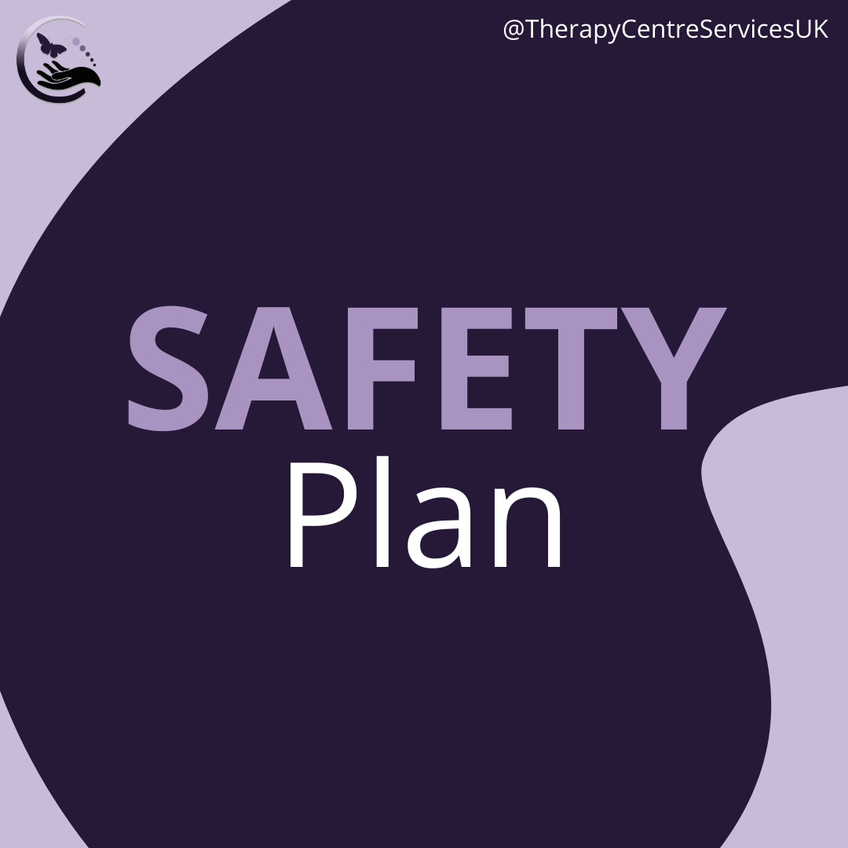
A toolkit to explain what a safety plan is, why it works and how to create one with your Counsellor.
When the thoughts of suicide feel too much, using this plan during those time can help.
What are my triggers?
What thoughts / feelings or triggers do I have that are my warning signs?

1.
2.
3.
4.
5.

What can I do to distract myself?
What can I do to distract myself, what coping strategies can I use? What has worked in the past? Is there anywhere I can go that will feel safe?
1.
2.
3.
4.
5.

How can I make my environment safer?
What would make it harder to act on my plans? Where could I put things that I could use to harm myself so they are harder to get to if I feel overwhelmed?
1.
2.
3.
4.
5.

Who can I contact?
Who can I reach out to for help? Who has helped in the past? What helplines or emergency contacts can I use?
1.
2.
3.
4.
5.

What other resources are available?
What help do I want now, and what resources can I access? What longer term support do I want? How might I access this?
1.
2.
3.
4.
5.

If you are feeling suicidal it is really important to tell someone.
Help and support is available right now if you need it. You don’t have to struggle with difficult feelings alone.
Samaritans – 116 123
Call your GP or call 111 out of hours
Talk to someone you trust (a friend, family member)
Book a counselling appointment with your Counsellor

If you have harmed yourself contact 999 for an ambulance or ask someone to take you to A&E

