

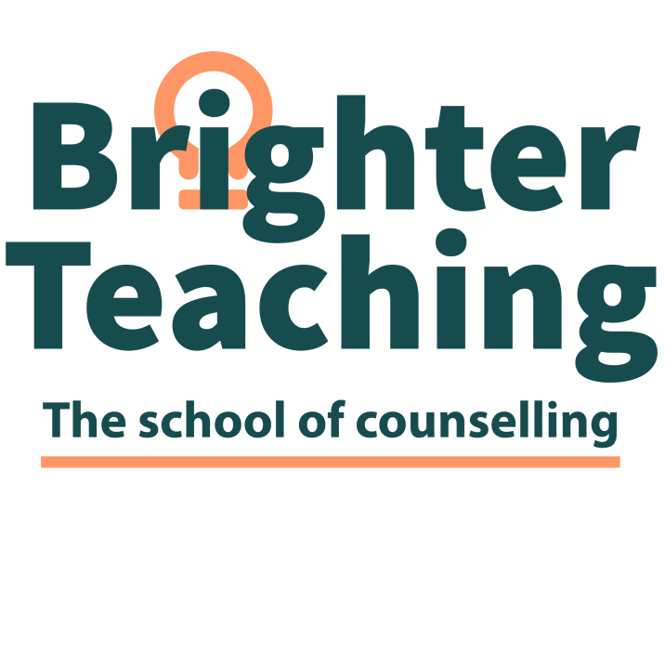

**Advanced Certificate in Gender, Sexuality an Relationship Diversities**

## **Who are Brighter Teaching**

Brighter Teaching is an independent education organisation specialising in teaching counselling theory and practice. We are committed to empowering our students to be the best they can be through educational attainment and self-growth. We believe in each student's potential and strive to empower them to succeed and reach their full potential.

Brighter Teaching oﬀers highly qualiﬁed, experienced, passionate and in professional practice counselling tutors, counsellors, supervisors and health & social care practitioners, all of whom are eager to share their knowledge and experience with you. We understand the diligence and commitment it takes to grow and ﬂourish, and we oﬀer a supportive environment to enable this to happen.

Brighter Teaching is devoted to oﬀering a place of learning which is accepting, inclusive and pro- motes equality and diversity. We believe our learners should be at the very heart of the organisation and we are unwavering in our commitment to empowering both students and staﬀ to ﬁnd their voice to be impassioned, motivated, courageous and creative***.***

**Who are SEG**

Skills and Education Group Awards, an awarding body. They are the UK leading sector specialist we continue to support employers and skills providers to enable individuals to achieve the skills and knowledge needed to raise professional standards across our sectors.

**What do you mean, Accredited Training Program (ATP)**

Allows Brighter Teaching to deliver our unique program to specific and valued learners in our own personal style. All courses are subjected to Internal and External Quality Assurance.

**Who is it for?**

The qualification is for those trained counsellors or newly qualified or student counsellors, and those who work in the helping sectors and want to learn more about supporting those who identify as LGBTQ+ (GSRD)

**You must complete 1 mandatory unit**.

Students are required to complete workshops. They will learn terminology, the history of LGBTQ+ and GSRD, the difference between sexuality and gender, the challenges of coming out, and the link between LGBTQ+, mental health, and intersectionality.

# **Course length**

5 months, students will need to attend workshops, usually on a weekend

# **Will I gain any qualiﬁcations?**

You will gain a certificate for working therapeutically with the GSRD community.

**Do I need any knowledge, skills, or qualiﬁcations?**

## No other prior knowledge is needed.

**How will I learn?**

You will be taught and supported by a tutor(s). You are expected to attend 80% of the course each year. Students learn from presentations and skills sessions by building a portfolio of evidence and completing speciﬁc tasks with the guidance of their tutor. The qualiﬁcation is blended online and face-to-face.

## **What materials or equipment will I need to provide?**

The most important resource you will have is your willingness to learn. You should also have a supply of pens and paper. A good internet connection and be ok with cameras being on at all times.

## **Your commitments as a learner**

To achieve success on the course, you will need to:

Attend regularly. Please let us know if you need to miss a session.

Have suﬃcient time for self-study and homework completion.

Complete the course.

Complete all the assessments.

Take part in the activities.

## **Fees**

The cost of the course changes according to the changes to the fees of the awarding body. Brighter Teaching fees are competitive. We cannot oﬀer funding or access to 24+ learner loans, but we have ﬂexible payment plans in which the costs can be spread over three years.

## If you wish to know more you can contact

[www.brighterteaching.co.uk](http://www.brighterteaching.co.uk/) [info@brighterteaching.co.uk](mailto:info@brighterteaching.co.uk)