# Who are Brighter Teaching

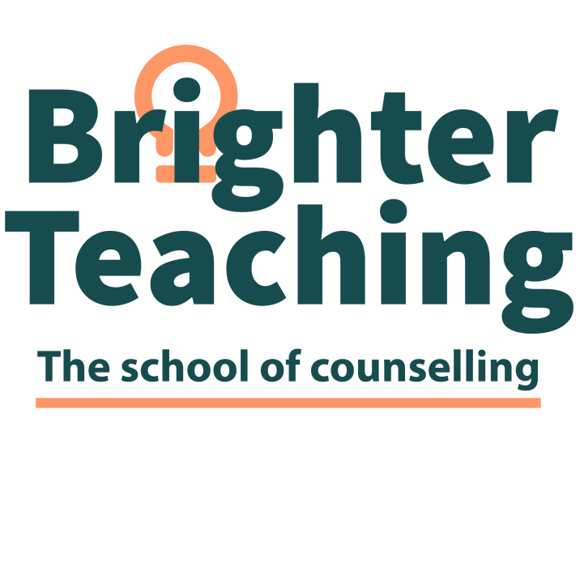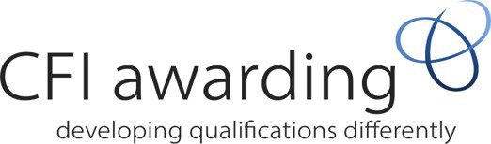

CFI Level 5 Diploma in Working Therapeutically with Couples and Relationships

Brighter Teaching is an independent education organisation that specialises in teaching counselling theory and counselling practice. We are dedicated to empowering our students to achieve their best through educational attainment and self-growth. We strongly believe in the potential of each student and strive to empower them to succeed and reach their full potential.

Brighter Teaching offers highly qualified, experienced, passionate professionals in counseling, including tutors, counsellors, supervisors, and health & social care practitioners who are eager to share their knowledge and experience with you. We understand the dedication and commitment it takes to grow and flourish, and we provide a supportive environment to make this happen.

Brighter Teaching is dedicated to offering a place of learning that is accepting, inclusive, and promotes equality and diversity. We believe our learners should be at the very heart of the organization, and we are unwavering in our commitment to empowering both students and staff to find their voice and be impassioned, motivated, courageous, and creative.***.***

Who are CFI Awarding

The course is fully accredited by CFI Awarding (Crossﬁeld Institute) Awarding Body. CFI Awarding is a registered charity founded in 2007; their philosophy fully aligns with that of Brighter Teaching

What do you mean, your qualiﬁcation is Ofqual regulated

The Oﬃce of Qualiﬁcations and Examinations Regulation (Ofqual) regulates qualiﬁcations, examinations and assessments in England. It oversees the correct functioning and conduct of awarding organisations and the quality of the certiﬁcation they oﬀer.

Who is it for?

This qualiﬁcation is designed for people who want to develop an in-depth understanding of counselling theory and practice in couples and relationship work. The qualification is for experienced and newly qualified counsellors.

What does the qualiﬁcation cover?

You must complete three mandatory units/modules:

Unit 1 Working with couples and other diverse relationships

Unit 2 Reflective practice and professional development

Unit 3 Working with couples and relationships in a therapeutic environment

Course length

15 months online or face-to-face, depending on the cohort. Students will complete 10 workshops over a full weekend, with three evenings of peer supervision.

Will I gain any qualiﬁcations?

You will gain a level 5 Diploma in Couples and Relationships.

Do I need any knowledge, skills, or qualiﬁcations?

You need to hold a level 4 or 5 in counselling.

How will I learn?

You will be taught and supported by a tutor(s). You are expected to attend 80% of the course each year. Students will learn from presentations and skills sessions by building a portfolio of evidence and completing speciﬁc tasks with the guidance of their tutor. The qualiﬁcation is face-to-face/online/blended; there will be elements of online workshops and skills practices.

You will be enrolled in an online library, and you will be able to have access to several books that will

assist with your qualiﬁcations.

Learners must complete 100 hours of placement working with couples from diverse backgrounds and intersections.

What materials or equipment will I need to provide?

The most important resource you will have is your willingness to learn. You should also have a supply of pens and paper. A good internet connection and be ok with cameras being on at all times.

Your commitments as a learner

* To achieve success on the course, you will need to:
* Attend regularly. Please let us know if you need to miss a session.
* Have suﬃcient time for self-study and completion of homework.
* Complete the course.
* Complete all the assessments.
* Take part in the activities
* Attend supervision while on the course
* Engage in personal therapy

Fees

The cost of level 5 changes according to the awarding body's fees. Brighter Teaching fees are competitive. We cannot offer funding or access to 24+ learner loans, but we have flexible payment plans to spread the costs over 15 months.

To register your interest or find out more information, please contact either [info@brighterteaching.co.uk](mailto:info@brighterteaching.co.uk) or [tommy@brighterteaching.co.uk](mailto:tommy@brighterteaching.co.uk)

Will I gain any qualiﬁcations?

The 7 units are divided into levels 4 and 5 units, a higher portion of the qualiﬁcation is at level 5 meaning you will gain a Level 5 Diploma.

Do I need any knowledge, skills, or qualiﬁcations?

You need to hold a level 3 in counselling or have completed counselling skills within another qualiﬁca- tion such as psychology or nursing.

How will I learn?

You will be taught and supported by a tutor(s). You will be expected to attend 80% of the course each year. Students will learn from presentations and skills sessions by building a porfolio of evidence and completing speciﬁc tasks with the guidance of their tutor. The qualiﬁcation is face-to-face. There will be elements of online workshops and skills practices.

You will be enrolled in an online library, and you will be able to have access to several books that will

assist with your qualiﬁcations.

Learners will need to complete 20 hours of personal therapy, throughout the course. A minimum of 6 sessions must be completed before you go into placement.

What materials or equipment will I need to provide?

The most important resource you will have is your willingness to learn. You should also have a supply of pens and paper. A good internet connection, and be ok with cameras being on at all times.

Your commitments as a learner

* To achieve success on the course, you will need to:
* Attend regularly. Please let us know if you need to miss a session.
* Have suﬃcient time for self-study and completion of homework.
* Complete the course.
* Complete all the assessments.
* Take part in the activities
* Attend supervision while on the course
* Engage in personal therapy

Fees

The cost of the level 5 changes according to the changes to fees of the awarding body. Brighter Teaching fees are competi- tive. We are unable to oﬀer funding or access to 24+ learner loans, but we have ﬂexable payment plans, in which the costs can be spread over the three years.

Progression

On complication of the Level 5 Diploma in Psychotherapeutic Integrative Counselling Theory and Prac- tice. You will able to become a member of BACP or NCSP, but you will need to complete an extra 250 hours of clinical practice as a trained paid counsellor before moving towards accreditation (SCoPEd Moving from A (member) to B (Accredited member) https://[www.bacp.co.uk/media/14435/scoped-](http://www.bacp.co.uk/media/14435/scoped-) framework-january-2022.pdf

**Brighter Teaching also oﬀers the following qualiﬁcations and a number of CPD courses**

L6 Counselling and applied psychology

L6 Psychosexual and relationship therapy

L6 Clinical Supervision ( 2 years experience needed)

# If you wish to know more you

can contact

[**www.brighterteaching.co.uk**](http://www.brighterteaching.co.uk/)

[**info@brighterteaching.co.uk**](mailto:info@brighterteaching.co.uk)